1. Web address- web.seesaw.me  or Google Seesaw | 2. Log in using QR code to scan or written log in that has been provided
3. You will access you child’s journal. Here you can see their work.  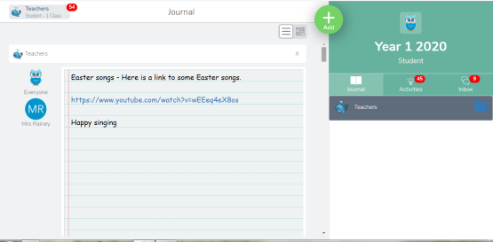 | 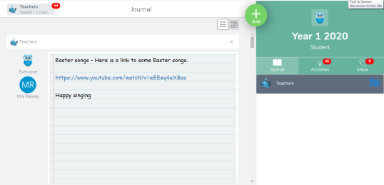  4. To post work that you have taken a picture of/recorded, click on the green plus sign.
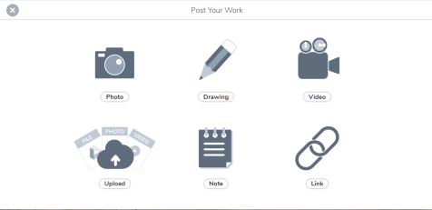  5. To take a picture of work, select photo or you can upload from you camera roll if you have taken the picture already by selecting upload. | 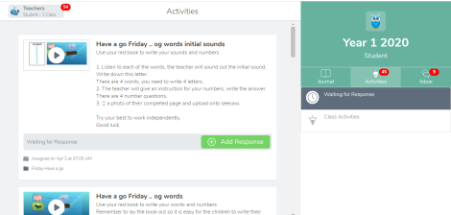  6. To access activities set by the teacher, click activities.
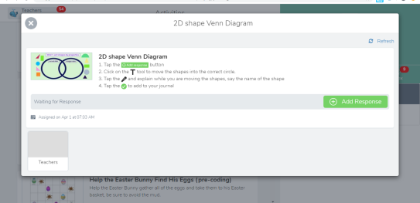  7. Instructions should be provided. Follow carefully as they will guide you through the task. To complete click ‘Add Response’ | 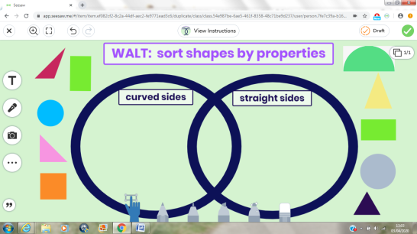  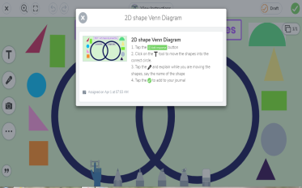  8. Once in the task, you can get a reminder of instructions by clicking ‘View Instructions’
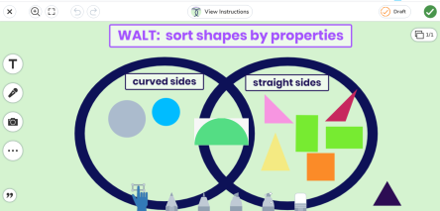  9. When task is complete, click the tick to submit work. You may need select a folder e.g Literacy, Numeracy | 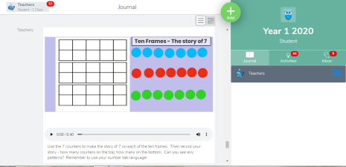  10. Voice instructions may also have been recorded by the teacher.
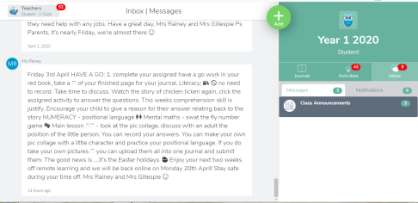  11. Your teacher may also send messages with instructions. You can check these by clicking ‘Messages’. | 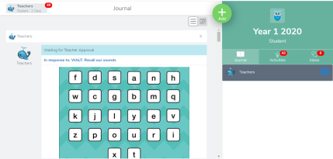  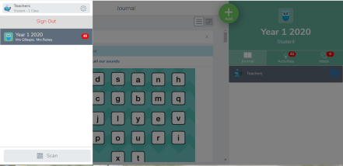  12. To log out, click your child’s name on the top left of the screen. Then click sign out.
13. Once activites are complete the teacher must approve them. You may receive a comment back. If an errors needs fixed you can select the 3 dots.  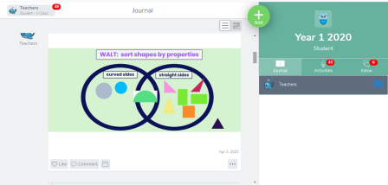 | 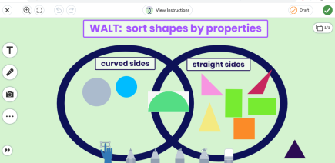  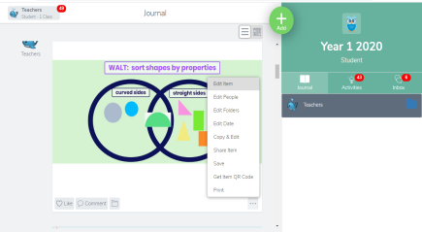  14. To edit an activity you have already submitted, select ‘Edit Item’. Once complete, select the green tick.

