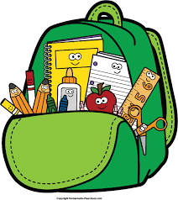
P5
Welcome
Booklet

Welcome to an exciting year in P5!

You have lots to look forward to as you move up the school. We will all work together to make school as fun and exciting as possible!

In P5 we have two classes that work alongside each other and complete the same work.

Classes

P5SW
P5SW’s teacher is called Miss Williams.
P5SW’s classroom assistant is Mrs Stevenson.

P5W
P5W’s teacher is called Mr White.
P5W’s classroom assistant is called Mrs Hilditch and Mrs Hannah.

Healthy Snack
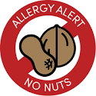
We have a healthy snack policy in Nettlefield Primary School. Please send your child with a piece of fruit or a small sandwich. No fizzy drinks.

Please remember we are NUT AWARE school. Please be especially vigilant as we have children and staff who are allergic to nuts.

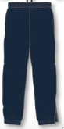
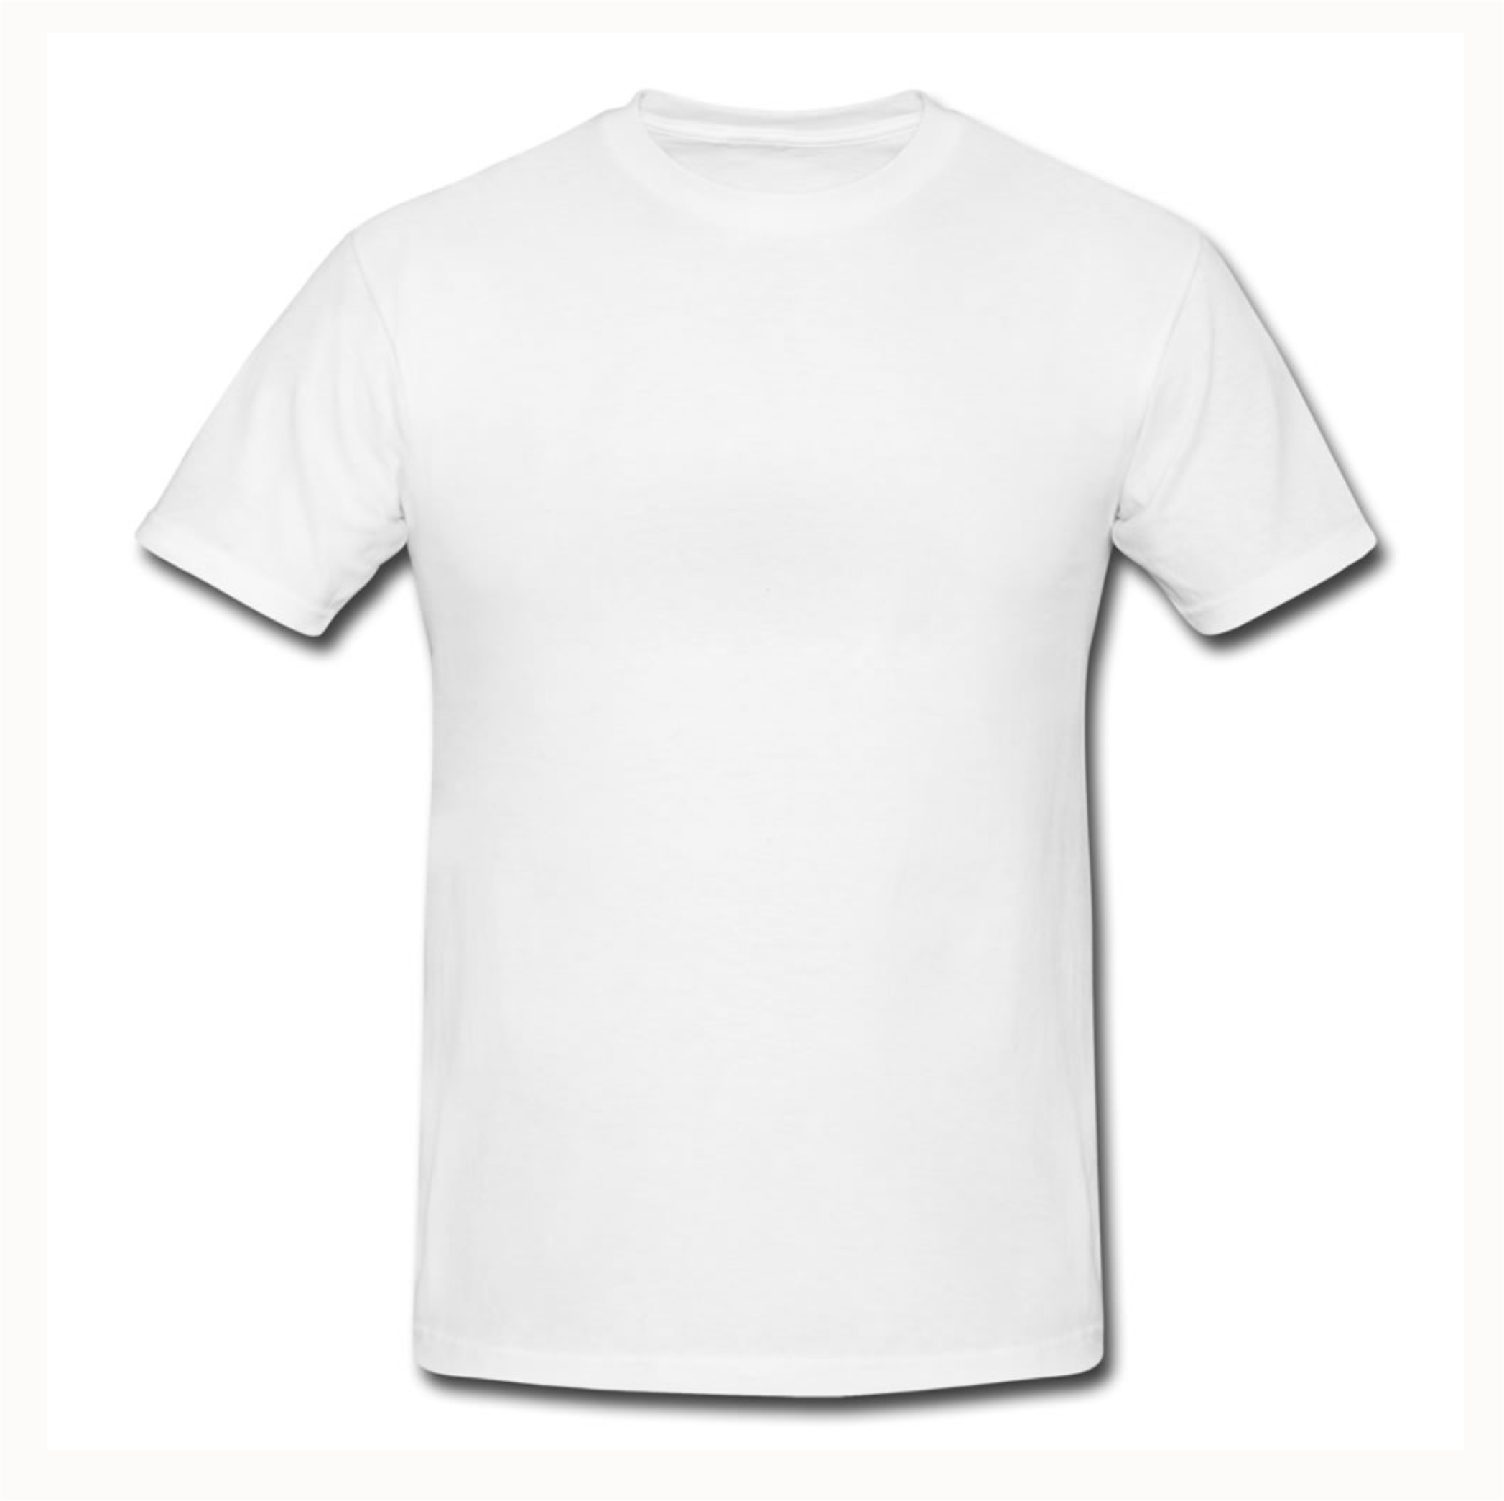
PE Days

Please come to school in your PE gear.
P5SW- Wednesday
P5W- Wednesday
Plain black/navy bottoms, a plain white t-shirt, trainers and your school jumper for warmth.
No football kits please.
If attending Josh’s children can wear a PE kit or change at the end of the school day.

Swimming for both classes will be on a Thursday.

Numeracy
During your P5 year we will be continuing to develop our numeracy skills. We will keep working on addition, subtraction, multiplication and division but we will be using much bigger numbers. We will also learn about fractions, percentages and decimals. It is really important that we keep learning our tables and table facts as this will make classwork easier and help us to calculate answers much quicker.
Literacy
We split Literacy up into three elements: Reading, Writing and Talking and Listening.
This year is about becoming more independent in general, improving fluency and understanding. To help at home try to read for at least 10 minutes a day and ensure you are always practising your handwriting and spellings.
UICT
We learn a wide range of skills in ICT over the year ranging from Word Processing and Desktop Publishing to Coding and Audio-Visual work. We are very lucky to have a suite of Chromebooks in our room to use every day.
RE
RE takes place in school. The children learn about people from the bible and their stories.
World Around Us
We teach a lot of cross curricular skills through our topics. We will be learning lots of new exciting things this year… check them out!

Sept- Oct | Nov - Dec | Jan - Feb
Water  Learning about the Water Cycle, water uses and environmental issues like flooding. | Victorians  Learning about the importance of the Victorian era and their many inventions. | Egyptians  Learning all about the Ancient Egyptians from Mummification hieroglyphics and study the Pharaohs.
March - April | May- June
Birds/Flight  Learning about birds and how they can fly | Vikings and Plants  Learning about Viking life. What types of homes they lived in and weapons they used for fighting  All about parts of a plant and how they grow.

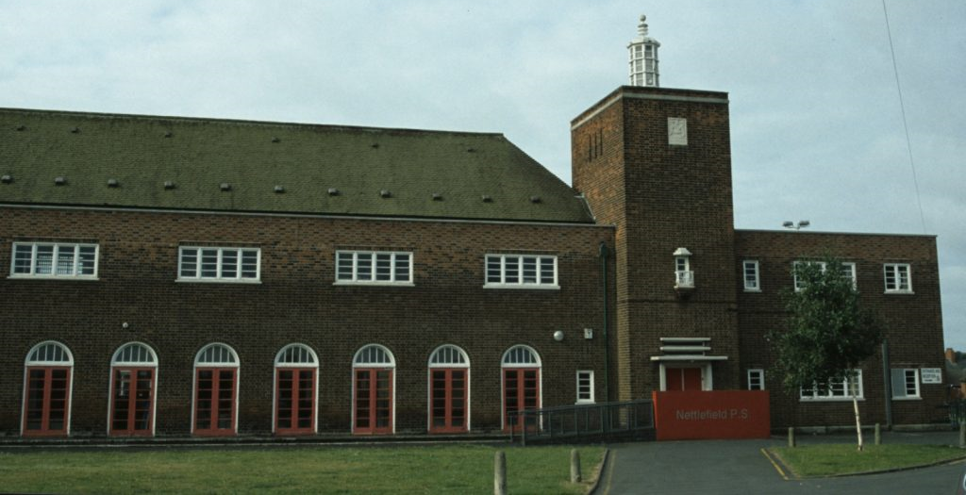
Things you need in school
- School bag
- Pencil case
- HB pencils*
- Sharpener (with holder for sharpenings)
- Rubber*
- 30cm ruler (no flexible rulers please)
- Highlighters
- Packet of colouring pencils *
- Pritt stick*
- White board pen
- Box of tissues and a hand soap
* The items starred will need to be replaced when they run out.

Things you need at home

We would recommend you have….
- Pencil case
- HB pencils
- Sharpener
- Rubber
- 30cm ruler
- A highlighting pen
- A dictionary
- Packet of colouring pencils
- Pritt stick

Homework
Homework planners will be sent via Seesaw and paper copies given to children.
I will give homework out on a Friday to be handed back in on a Friday.

Your child’s email login is:
Your child’s initial of their first name and their surname and three unique numbers followed by the mail address
Eg:
For John Smith
jsmith584@c2ken.net

The password is nettlefield123

Children will have homework folders and will be expected to complete these on the assigned day and bring them back into school the following day.
If you have any problems, please contact us via the Seesaw family app and we will help out as best as we can!

HELPFUL SCHOOL LINKS/ RESOURCES
Accessing My School from home (C2K)
Open your web browser and go to www.c2kschools.net
Enter your C2k Username and Password to log in to MySchool.
Example Username: jbloggs123@c2kni.net
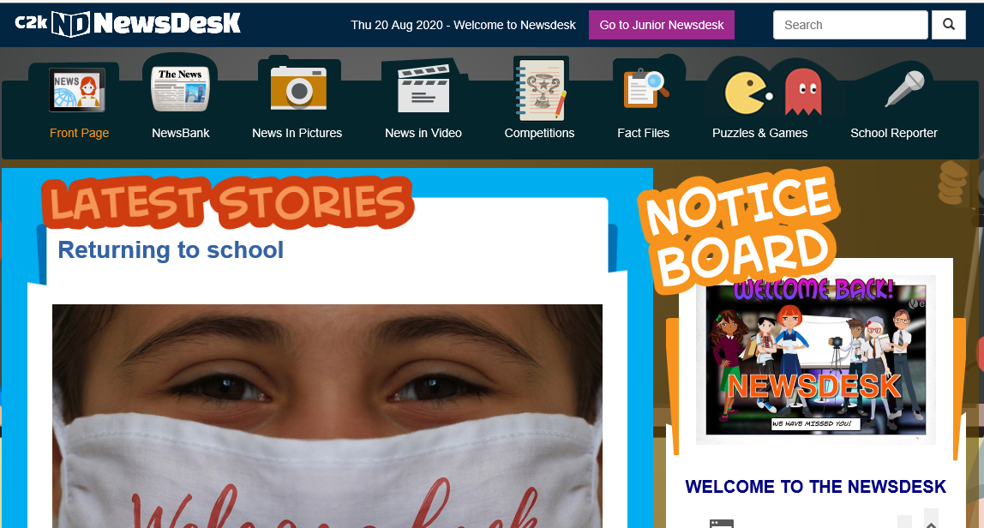
Password: joeP5
This will give you access to all of the apps that you have in school, including Newsdesk, which is a great place for reading, topic information and news.

https://www.bbc.co.uk/bitesize/subjects/zv48q6f/year/zhgppg8
https://www.topmarks.co.uk/english-games/7-11-years/spelling-and-grammar
https://pbskids.org/games/reading
https://www.abcya.com/games/category/writing
https://www.funenglishgames.com/writinggames.html

NETTLEFIELD PRIMARY SCHOOL

USEFUL INFORMATION
(A) If you have a concern about anything in school, please follow these procedures:
(i) Speak to your child’s class teacher.
(ii) Vice-Principal - Mrs Fullerton
(iii) Speak to (Principal) - Mr McLean
(B) Should your concern not be resolved then:
You may have a concern that should involve the Board of Governors of the school. Please put this in writing to the Secretary of the Board of Governors. This will be discussed at the next meeting with the chairman and a response made by him concerning the issue. Mrs M. McCartney (Chairperson).
(C) If you have a concern about a Child Protection matter in or out of school;
please contact:
(i) Mrs Fullerton - Designated Teacher for Child Protection.
(ii) Mr McLean - Deputy Designated Teacher.
(iii) Mrs Cardy - Deputy Designated Teacher.
The Designated Teachers will ensure the matter is completely investigated with support from the Education Authority and the appropriate outside agencies.
* If you ever suspect your child is being bullied at school – please contact the class teacher or Mr McLean immediately.

NETTLEFIED PRIMARY SCHOOL
MEDICAL ISSUES
Please ensure you follow our medical procedures guidelines if your child has a medical condition.
(i) Ensure the school is fully aware of the condition and its implications in school.
(ii) Ensure a yellow medical form is completed for any medication being requested to be administered in school.
(iii) Ensure inhalers etc are provided for the class teacher, should an emergency arise.
Contact Mr McLean for any further advice.

CARE REQUESTS
It is parental responsibility to ensure the school office/teachers are aware of any changes to collecting arrangements for your child in the afternoon.
Phone calls to change arrangements at the last minute are not welcome unless in an absolute emergency.
Please ensure your child knows who is collecting him/her at the end of the day. This provides comfort and stability for the school day.
Nettlefield Primary School
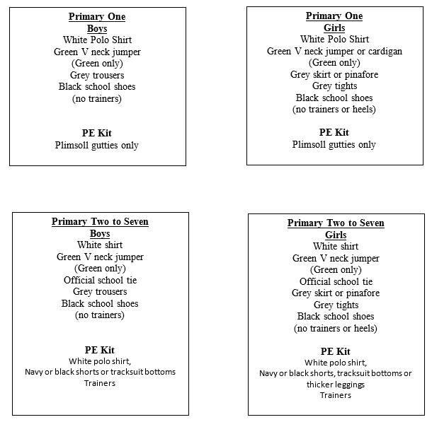
Uniform 2023- 234
Please note: After parent consultation as well as for health and safety reasons, the wearing of ear rings or any other jewellery is not permitted at Nettlefield. If there is an exceptional reason that your child must wear an earring to school, they must be covered with a plaster.
‘Number One’ grade haircuts, hair colours or artistic designs shaved into heads are also unacceptable.

Nettlefield Primary School
Anti – Bullying Procedures
As a school, we are very pro-active concerning the issue of bullying. All classes are taught not to engage in such behaviour, but also what to do, should it unfortunately still occur. When an incident is reported, the following will take place:
The class teacher will speak to the bully and the victim involved. Bystanders may also be involved in this discussion. Clear guidance will be given that this type of behaviour should cease immediately. If a child (victim) is distressed at this level – parents will be informed. The parent of the bully will be contacted immediately to ensure the incident is dealt with at home.
Should this type of incident continue, the class teacher will inform the Head of Stage/Vice Principal/Principal. The bully will be punished in line with our Positive Behaviour Policy and parents will be invited into school for a meeting. No child will be permitted to persistently annoy/upset another child in our school.
The positive ethos encouraged helps to eradicate the need for this type of behaviour but when it occurs, both the victim and the bully get help to ensure it does not continue. A bully often has other issues and these will be investigated to ensure this behaviour pattern stops.

